KRMI -

Functionality
This transaction gives you the actual line items on the Product Cost Collectors created for particular material and production version.
In Product Cost Controlling costs are collected on Product Cost Collectors with order types:
RM01 - PCC for Repetitive Manufacturing
RM01 - PCC for Process Orders
CP01 – CO Production Orders
Scenario
Material MEG 22000055 produced in plant 1200 with production version is used as an example.
Requirements
None.

Menu Path | Accounting → Controlling → Product Cost Controlling → Cost Object Controlling → Product Cost by Period → Information System → Reports for Product Cost by Period → Line Items → Product Cost Collectors → KRMI - Actual Costs
Transaction Code | KRMI

1. Double click on KRMI - Actual Costs.

Display Actual Cost Line Items for Orders: Initial Screen

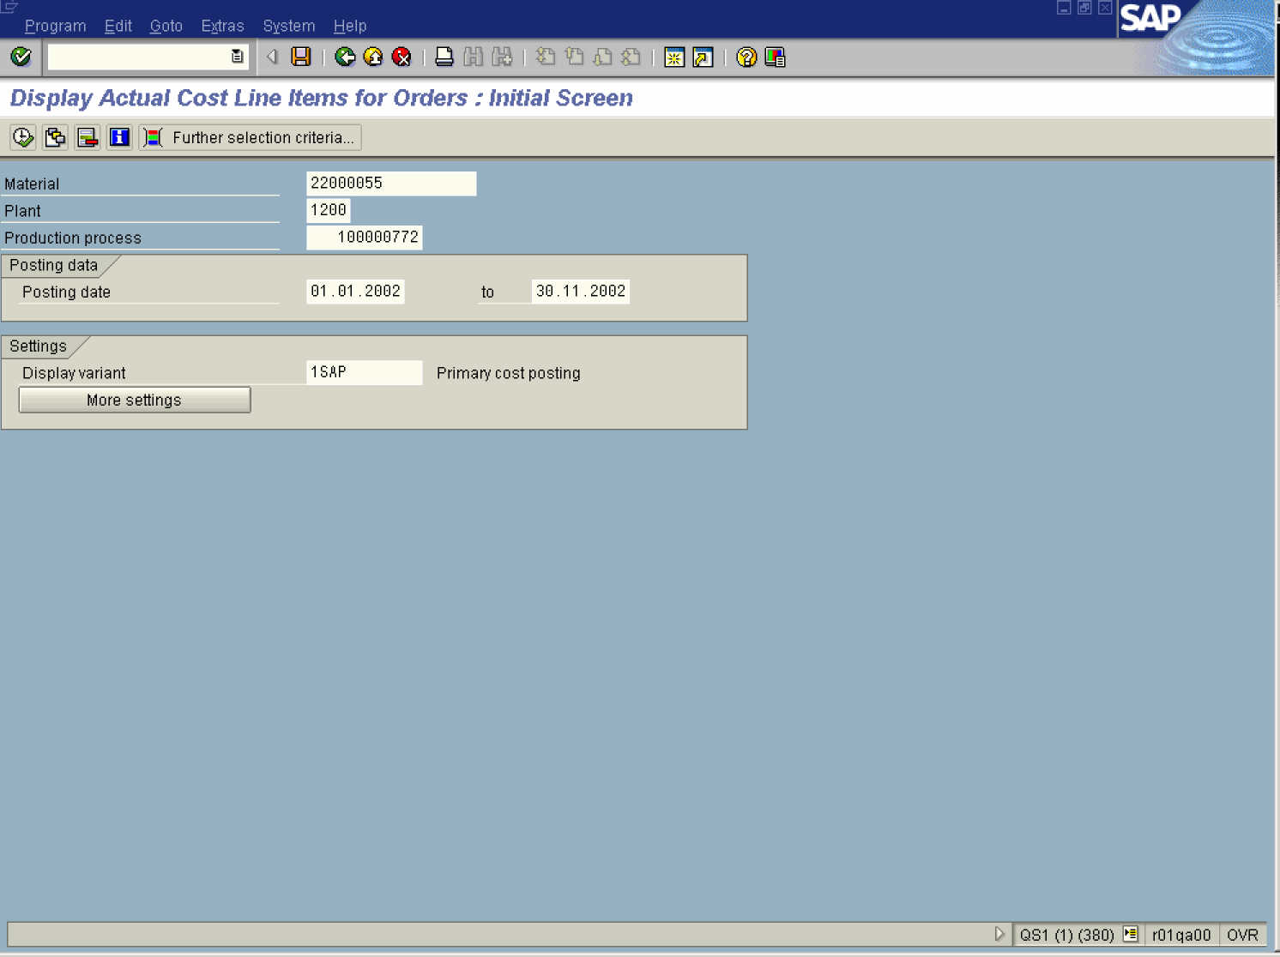

2. Update the following fields:

Field Name | Description | Values
Material | Code identifying material number | Example: 22000055
Plant | Code identifying the operational unit of the company where the material is manufactured and stored | Example: 1200

Restrict value range (1)

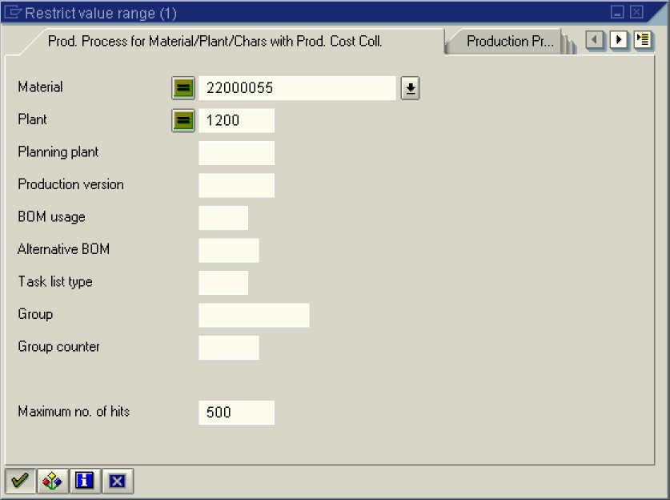

3. Click the Enter button.

Restrict value range (1) 4 Entries found

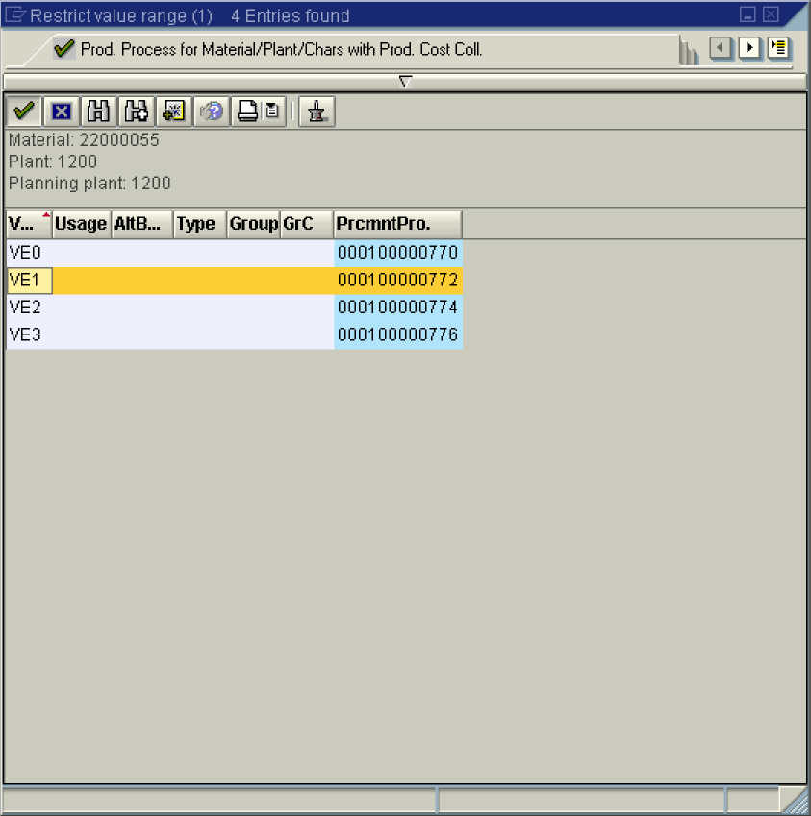

4. Double click on the Production version VE1 – 000100000772 in list box.

5. Click the Continue button.

Display Actual Cost Line Items for Orders: Initial Screen

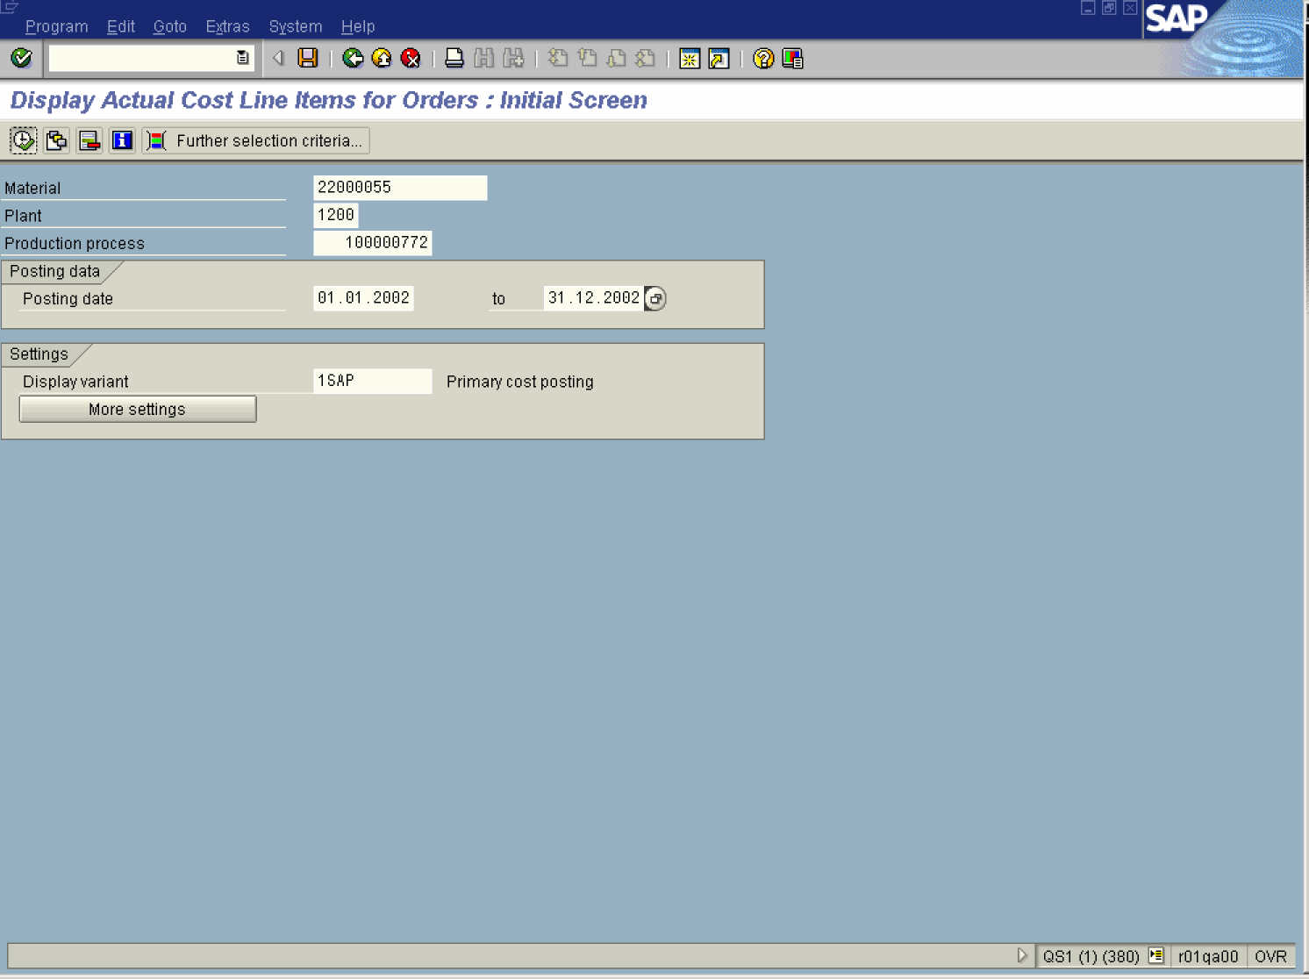

6. Click the Execute button.

Display Actual Cost Line Items for Orders

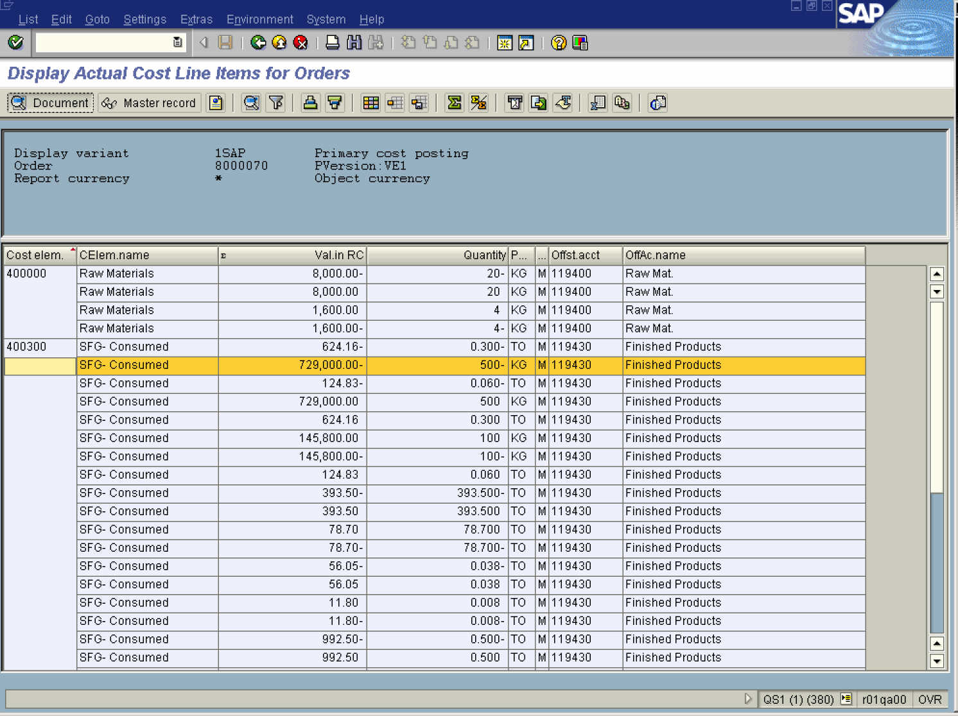

7. Select the SFG- Consumed - 729,000.00 - 500 - KG - M - 119430 - Finished Products entry in list box.
8. Click the Document button.

Display Material document 4900000181 - SBTP00155

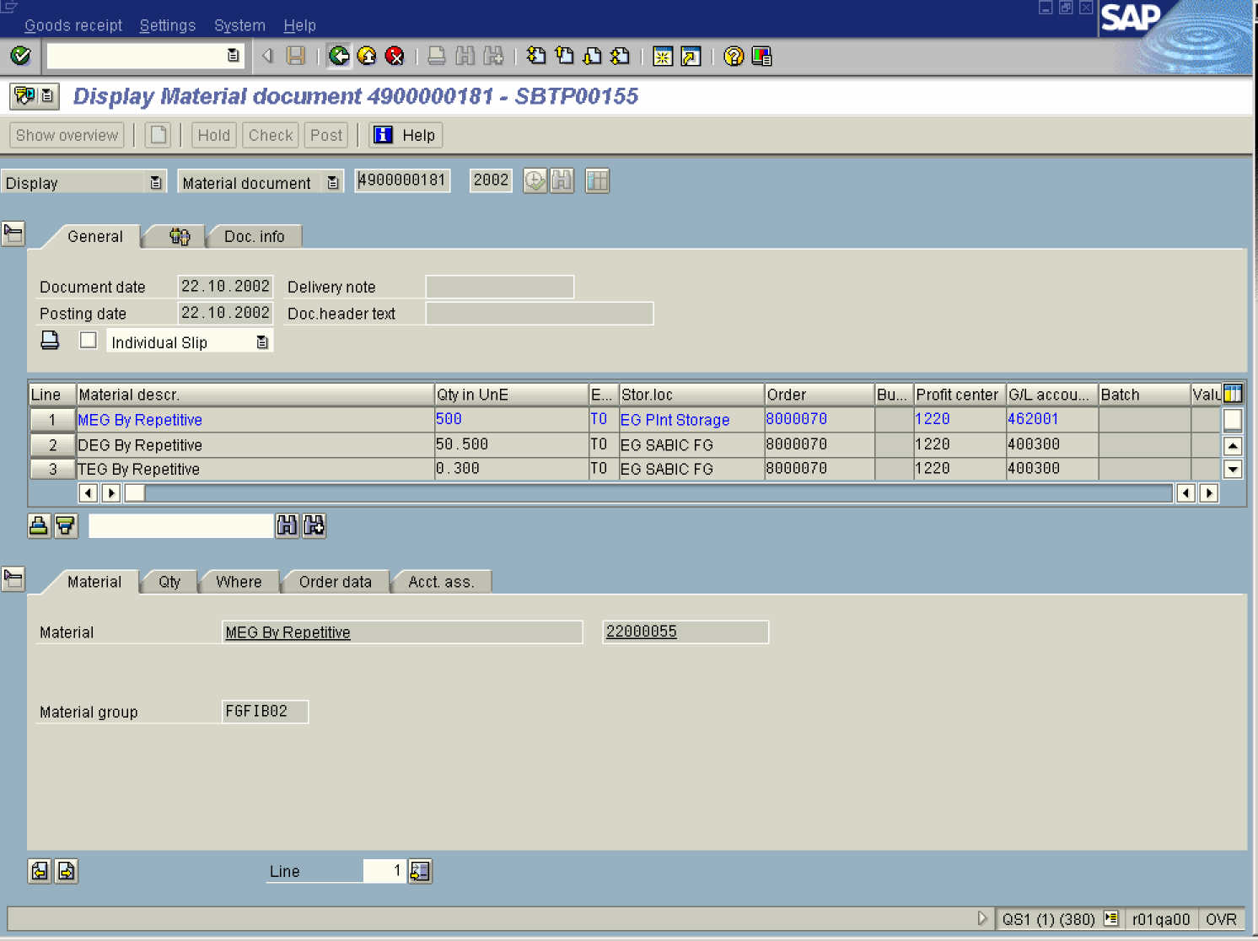

9. Click the Back button.

Display Actual Cost Line Items for Orders

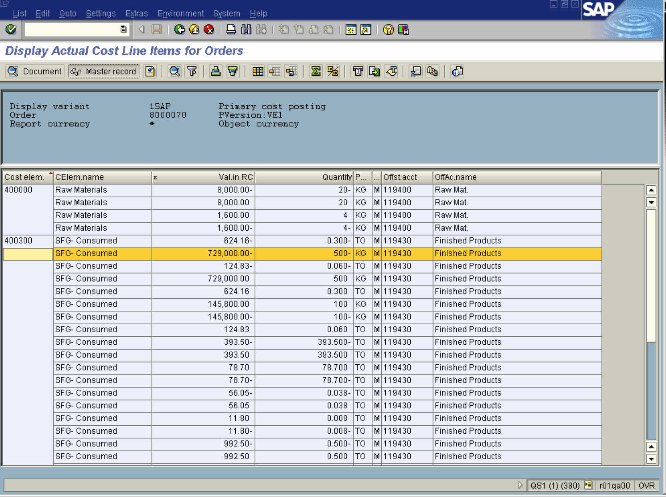

10. Click the Master record button.

Display Cost Element: Basic screen

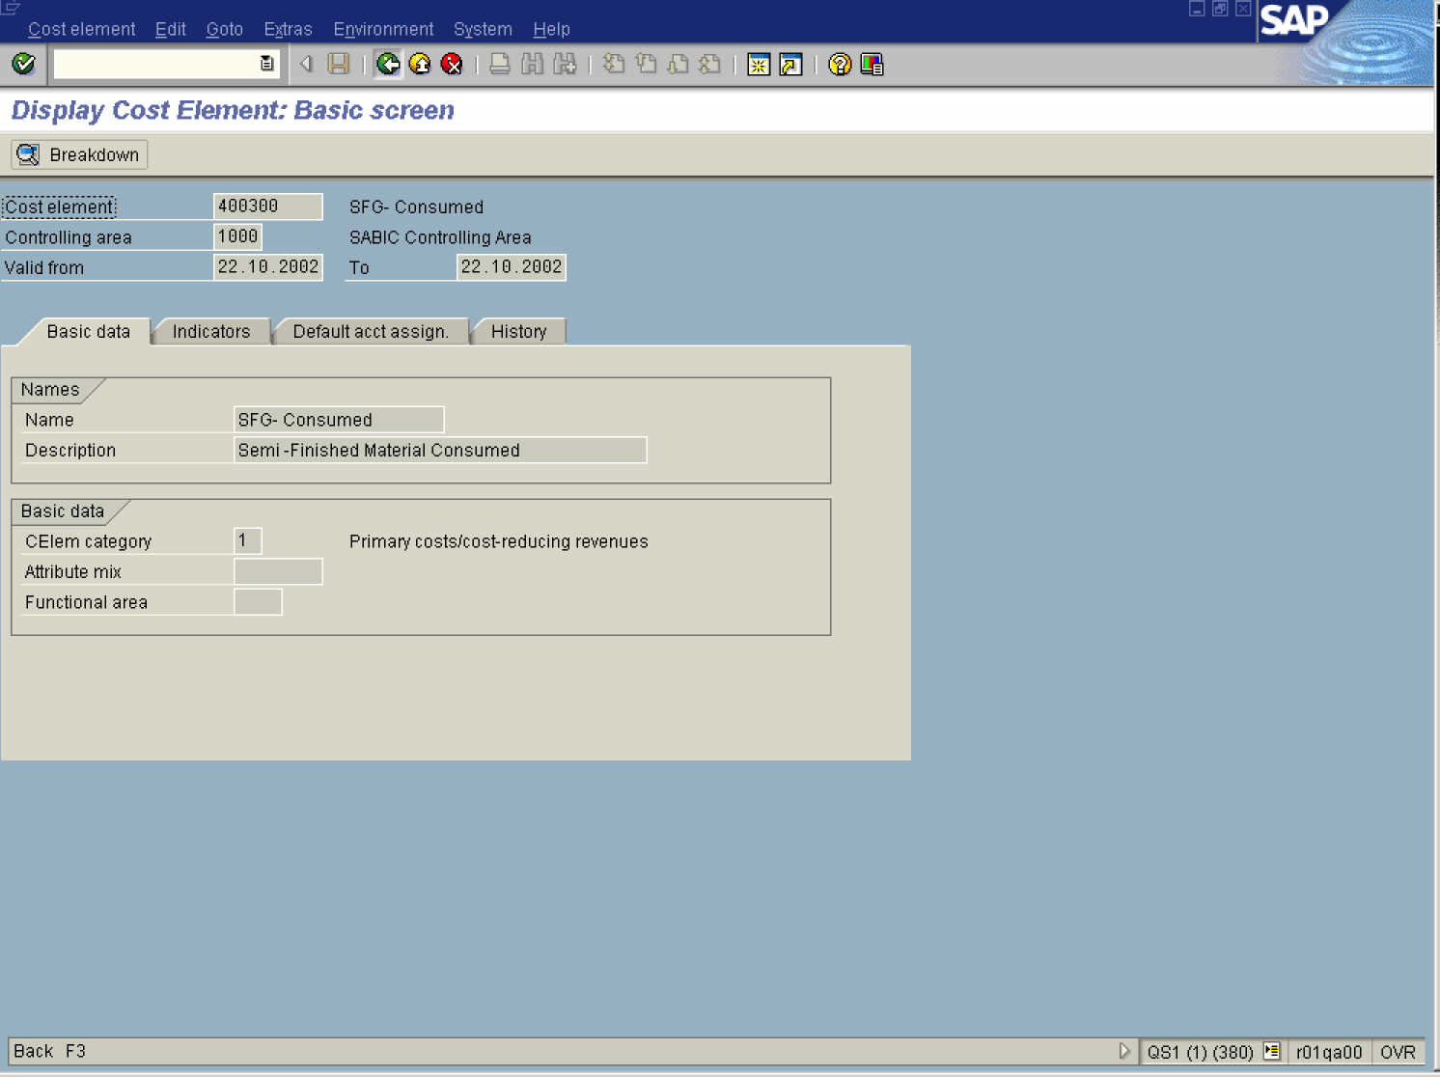

11. Click the Back button.

Display Actual Cost Line Items for Orders

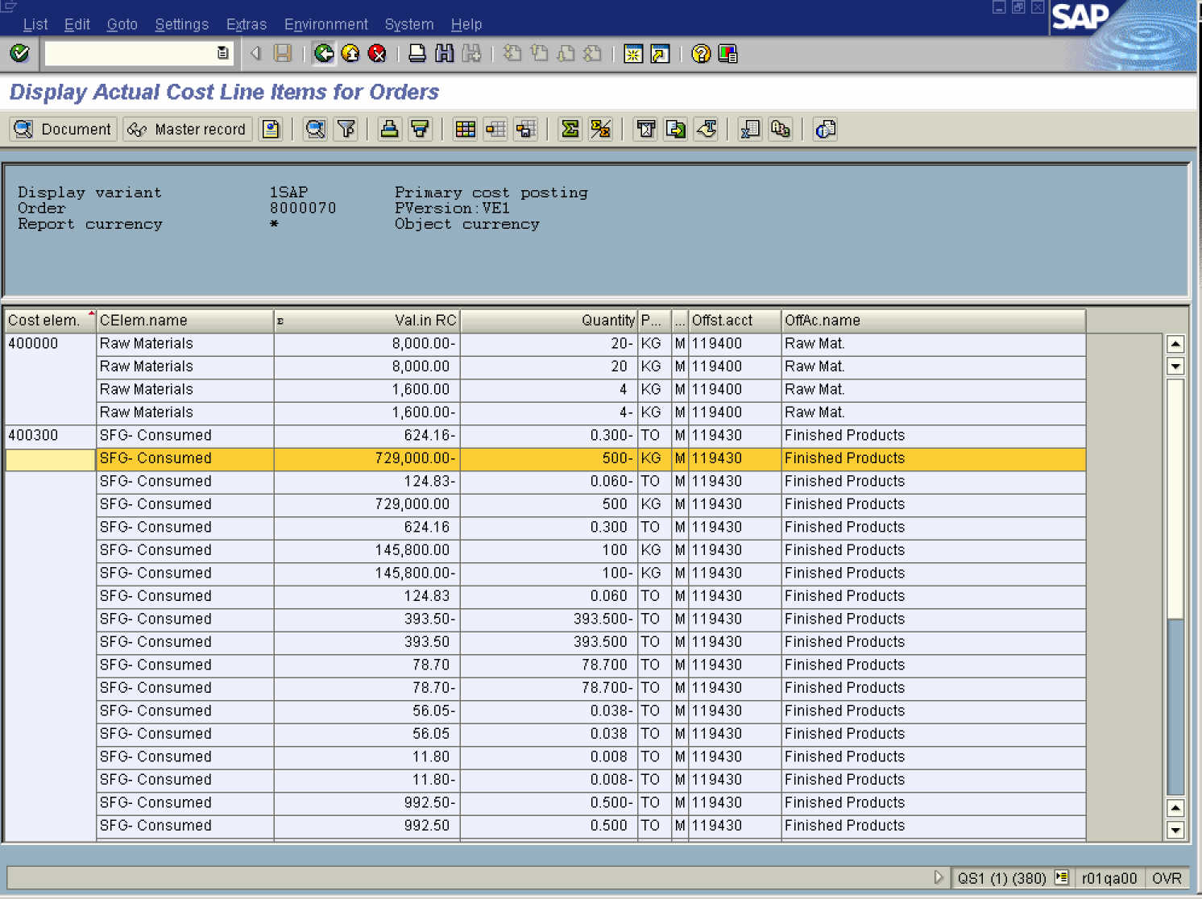

12. Click the Back button.

Display Actual Cost Line Items for Orders

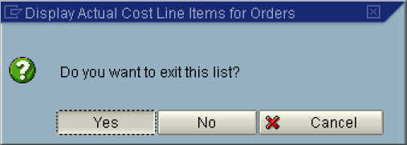

13. Click the Yes button.

Display Actual Cost Line Items for Orders: Initial Screen

14. Click the Back button to go back to SAP Easy Access screen.

